EXPT NO:4 | TRANSFORM DATA TO SUIT BI REPORTING REQUIREMENTS AND  DESIGN A DASHBOARD WITH KEY PERFORMANCE INDICATORS (KPIs ) USING TABLEAU AND POWERBI
DATE: 24.07.2026

PRE-LAB QUESTIONS (PROVIDE BRIEF ANSWERS TO THE FOLLOWING QUESTIONS)

- What is the role of data transformation in BI reporting?
Data transformation is the process of converting raw data into a clean, structured, and meaningful format suitable for analysis and reporting. It includes tasks such as filtering, sorting, merging, renaming columns, changing data types, and creating calculated fields. Proper data transformation improves data quality and helps generate accurate dashboards and reports.

- What are the common data cleaning techniques in Tableau and Power BI?
Common data cleaning techniques include:
- Removing duplicate records
- Handling missing (null) values
- Correcting inconsistent data
- Renaming columns
- Changing data types
- Filtering unwanted records
- Replacing incorrect values
- Splitting or merging columns
- Creating calculated fields for cleaned data
Tableau uses Data Interpreter and calculated fields, while Power BI mainly uses Power Query Editor for data cleaning.

- How do Tableau and Power BI handle data aggregation?
Tableau and Power BI automatically aggregate numerical data using functions such as SUM, AVERAGE, COUNT, MIN, and MAX. Users can also change the aggregation method depending on the analysis. Aggregation helps summarize large datasets into meaningful information. For example, total sales can be calculated by region or average profit by category. This makes reports easier to understand and supports better decision-making.
- What are KPIs, and why are they important in a dashboard?
Key Performance Indicators (KPIs) are measurable values used to track the performance of a business or process. They help users monitor progress toward specific goals and objectives. KPIs provide quick insights into important metrics such as sales, profit, and customer satisfaction. They make dashboards more informative and support better decision-making.

- What are the different types of charts available in Tableau and Power BI for visualization?
- Bar Chart – Compares categories.
- Line Chart – Shows trends over time.
- Pie Chart – Shows proportions or percentages.
- Scatter Plot – Shows relationships between variables.
- Area Chart – Shows trends with volume.
- Tree Map – Compares categories by size.
- Heat Map – Highlights patterns using colors.
- Map – Shows data by location.
- Histogram – Shows data distribution.
- Table/Matrix – Displays detailed data.
- KPI Card – Shows key business metrics.
- Gauge Chart – Compares value with target.
- Donut Chart – Shows category proportions.
- Funnel Chart – Shows process stages.
- Waterfall Chart – Shows increase and decrease in values.
These charts help visualize trends, comparisons, distributions, relationships, and business performance effectively.

IN-LAB EXERCISE:
OBJECTIVE:
To transform COVID-19 data into a structured format suitable for Business Intelligence (BI) reporting and design interactive dashboards with Key Performance Indicators (KPIs) using Tableau and Power BI.
PROCEDURE:
- Data Collection:
  - Import the COVID-19 dataset from inbuilt sources like Our World in Data or CSV files containing country-level COVID statistics (e.g., new cases, deaths, vaccinations).
  - Datasets may include fields such as date, location, new_cases, total_cases, new_deaths, total_deaths, people_vaccinated, etc.
- Data Cleaning and Transformation:
  - Convert columns like date to proper date formats.
  - Handle missing or null values in new_cases, total_cases, etc.
  - Create calculated fields (e.g., daily case growth rate, case fatality rate, vaccination percentage).
- Data Aggregation:
  - Aggregate data by continent, country, or month.
  - Use measures like SUM(new_cases), AVG(positivity_rate), MAX(total_deaths).
- Designing KPIs:
  - Identify KPIs such as:
    - Total Confirmed Cases o Total Deaths o Case Fatality Rate o Vaccination Coverage (%)
    - Daily Case Growth Rate
  - Use DAX (Power BI) or Calculated Fields (Tableau) to compute and visualize these KPIs.
- Dashboard Development:
  - Build visualizations such as:
    - Line charts for daily new cases and deaths o Bar charts for country-wise vaccination progress o Maps to show regional case distribution
    - KPI cards for high-level insights
  - Use filters (e.g., by continent, country) and slicers (e.g., by date range) for interactivity.

- Publishing and Sharing:
  - Publish the dashboard using Tableau Public/Server or Power BI Service.
  - Share the dashboards with stakeholders through public or organizational portals.
Experiment Dataset: COVID-19 Global Dataset
Fields Used:
  - Date – Date of the report
  - Location – Country or region
  - New Cases – Daily reported cases
  - New Deaths – Daily reported deaths
  - People Vaccinated – Cumulative vaccinated count
  - Total Cases – Cumulative confirmed cases
  - Total Deaths – Cumulative deaths
  - Population – Total population of the country

Power BI
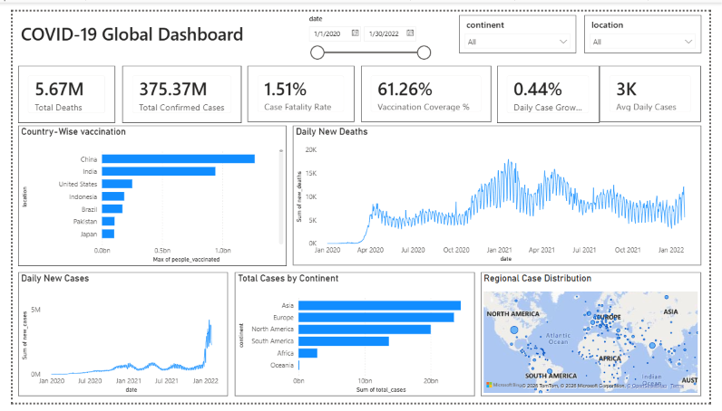

TABLEAU
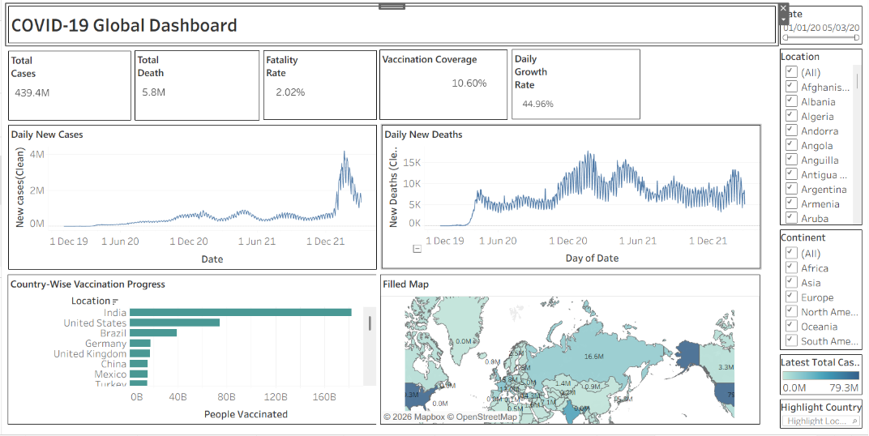

POST-LAB QUESTIONS (PROVIDE BRIEF ANSWERS TO THE FOLLOWING QUESTIONS)
  - How did data transformation improve the quality of insights in your COVID-19 dashboard?

Data transformation made the dataset clean and consistent for analysis. Converting date formats and handling missing values improved the accuracy of the visuals. Creating calculated fields such as vaccination coverage and case fatality rate provided meaningful insights. Aggregating data by country and continent made comparisons easier. Overall, the transformed data helped generate reliable and interactive dashboards.

  - What challenges did you encounter during the data cleaning process, and how did you resolve them?

The main challenge was dealing with missing values and inconsistent data formats. Some date fields and numeric columns required proper formatting before analysis. I removed or replaced missing values using the available data. Duplicate and unnecessary records were also cleaned to improve data quality. These steps ensured the dashboard displayed accurate and meaningful results.

  - Which KPI provided the most valuable insight, and why?

The vaccination coverage KPI provided the most valuable insight in the dashboard. It clearly showed the progress of vaccination across different countries. This helped compare how quickly each region responded to the pandemic. It also highlighted countries with lower vaccination rates. The KPI made it easier to understand the overall vaccination status at a glance

  - How does interactivity in dashboards improve user experience?

Interactive dashboards allow users to explore the data more effectively. Filters and slicers help focus on specific countries, continents, or time periods. Users can quickly identify trends without searching through large datasets. The dashboard becomes easier to understand and more engaging. This improves decision-making by providing customized insights instantly
  - What steps would you take to further enhance the dashboard’s effectiveness?

I would add more KPIs such as recovery rate and active cases for better analysis. Including drill-down features would allow users to explore data in greater detail. I would improve the visual design with clearer labels and consistent colors. Adding tooltips and trend comparisons would make the dashboard more informative. Regularly updating the dataset would ensure the insights remain accurate and relevant.

RESULT:

The COVID-19 dataset was successfully cleaned, aggregated, and transformed for visual analysis using Tableau and Power BI. Missing values, data type mismatches, and inconsistencies were addressed. KPIs such as vaccination rate and daily case growth offered valuable insights into the pandemic trends across countries and timeframes. The resulting interactive dashboards allowed for effective public health monitoring and communication.

ASSESSMENT

Description |  | Max Marks | Marks Awarded
Pre Lab Exercise |  | 5
In Lab Exercise |  | 10
Post Lab Exercise |  | 5
Viva |  | 10
 | Total | 30
 | Faculty Signature

